St. Francis Institute of Technology, Mumbai-400 103

**Department of Information Technology**

A.Y. 2024-2025

Class: TE-ITA/B, Semester: V

Subject: **Advanced DevOps Lab**

**Experiment – 8: To test python files with SonarQube and observe the results.**

1. **Aim:** To perform analysis of the code to detect bugs, code smells, security vulnerabilities on a Python application.
2. **Objectives:** After study of this experiment, the student will be able to
   * Understand static analysis of the code.
3. **Outcomes:** After study of this experiment, the student will be able to
   * Generate static analysis of the code with code smells, bugs, security vulnerabilities.
4. **Prerequisite:** Fundamentals of Software Testing
5. **Requirements:** PC and Internet
6. **Pre-Experiment Exercise:**

**Brief Theory:**

SonarQube is a static analysis code tool. It basically goes through developers' code and identifies errors at the early stage. It is an open-source static testing analysis software. It is used by developers to manage source code quality and consistency. Some of the code quality checks are:

* Potential Bugs
* Code defects to design inefficiencies — Identifies the code which is not compatible with the design structure of the application.
* Code duplication — Code duplications take a lot of memory. The tool can identify those things.
* Lack of Test Coverage — There maybe we are not enough tests written to application. The tool can identify those things.
* Excess complexity — Tool can identify a much more simple may to complex code segments.

## 

## Features of SonarQube

* **It can work in 25 different languages**. (Java, .NET, JavaScript, COBOL, PHP, Python, C++, Ruby, Kotlin and Scala)
* **Identify tricky issues.**

**Detect Bugs**— SonarQube can detect tricky bugs or can raise on pieces of code that it thinks is faulty.

**Code Smells**— Code smells are the characteristics of a code that indicates that there might be a problem caused by the code in the future. But smells aren’t necessarily bad, sometimes they are how the functionality works and there is nothing that can be done about it. This is something called best practices.

**Security Vulnerability** — SonarQube can detect security issues that code may face. As an example If a developer forgets to close an open a SQL database OR If important details like username and password have been directly written in the code. Then SonarQube can identify these things. Because leaving SQL database open can cause issues in the source code and you definitely do not want to write username and password directly in the code. You should inject them.

**Activate Rules Needed** — You can create and maintain different sets of rules that are specific to particular projects, these are known as **Quality Profiles**. This means a team or project should follow specific rules. Then we can create a Quality profile in SonarQube.

**Execution Path** — Whenever there is Data flow in your program, and there is a lot of involvement between the different Modules. SonarQube can figure out if there are any tricky bugs in these execution paths. When a company works on an application there obviously have a code pipeline a data flow in the program. SonarQube when it integrated to Jenkins or any deployment tool it works by itself it keeps looking on errors and bugs. Sometimes SonarQube identifies these tricky bugs in these pathways. Suppose an error that depends on Module that is way back in the code pipeline or way back in the data flow in the program then can figure out the integration error that happens between these.

* **Enhanced Workflow (Ensure Better CI/CD)**

**Automated Code Analysis** — Keep working in the background from the development phase itself, monitoring and identify errors. SopnarQube can be automated by integrating with the deployment tool or integration tool and it will keep working on the background and it finds all the errors, the Code Smells, Technical Dept by itself.

**Get access through Webhooks and API** — To initiate tests do not need to come to SonarQube directly, we can do that through an API call. You do not need to install SonarQube directly. You can just use APIs and call them.

**Integrate GitHub** — It can be directly integrated with your choice of version control software. You can find errors as well as the version of the code you are using.

**Analyze branches and Decorate pull request**s — It gives us a branch Level analysis. As an example, it does not just analyze the master branch it also analyzes the other branches, identifying any errors.

* **Built-in methodology**

**Discovery Memory Leaks**— It can show the memory leaks in your application if the application has a tendency to fail or go out of memory. This generally will happen slowly happen over a period of time.

**Good Visualizer** — It has a good way visualizing, it gives simple overviews of the overall health of the code. After the code has been developed a proper record of how the core is been performing created by SonarQube and it will be presenting on the Dashboard. So the team Lead or the Developer himself can go through it.

**Enforces a quality gate** — It can enforce a quality gate, you can tell SonarQube based on your requirements and practices what code is wrong and what is correct.

**Digs into issues**— If it shows that there is a problem SonarQube allows you to go and directly check it out from the summary report or from one code file to another. In the SonarQube summary dashboard, you can see furthermore details of the errors bu just clicking on the error.

**Plugins for IDEs** — It has a plugin called “SonarLint” which helps SonarQube to integrate itself with an IDE. Which means there is no need to install the whole SonarQube package.

1. **Laboratory Exercise**

Installation Steps

**Step A: Install Java 1.11.0.11 or upgrade Java to min. jdk1.11**

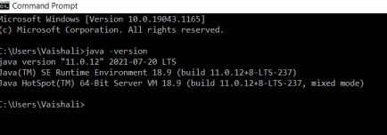

**Step B:** Download **SonarQube** from <https://www.sonarqube.org/downloads/>

**Step C :** Download **SonarScanner** from https://docs.sonarqube.org/latest/analysis/scan/sonarscanner/

**Step D: Extract Zip files in C:/Program Files/SonarQube folder and C:/Program Files /SonarScanner folder**

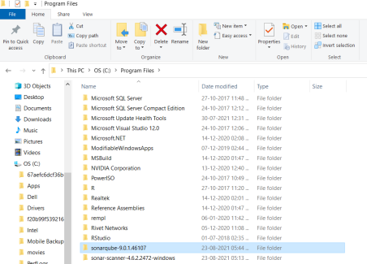

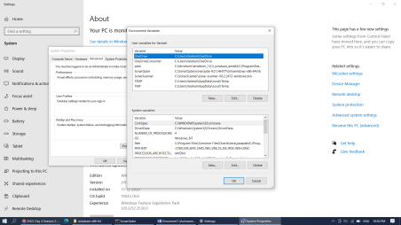

We installed and configured SonarQube and SonarScanner.

**Step 1: StartSonar server from SonarQube folder**

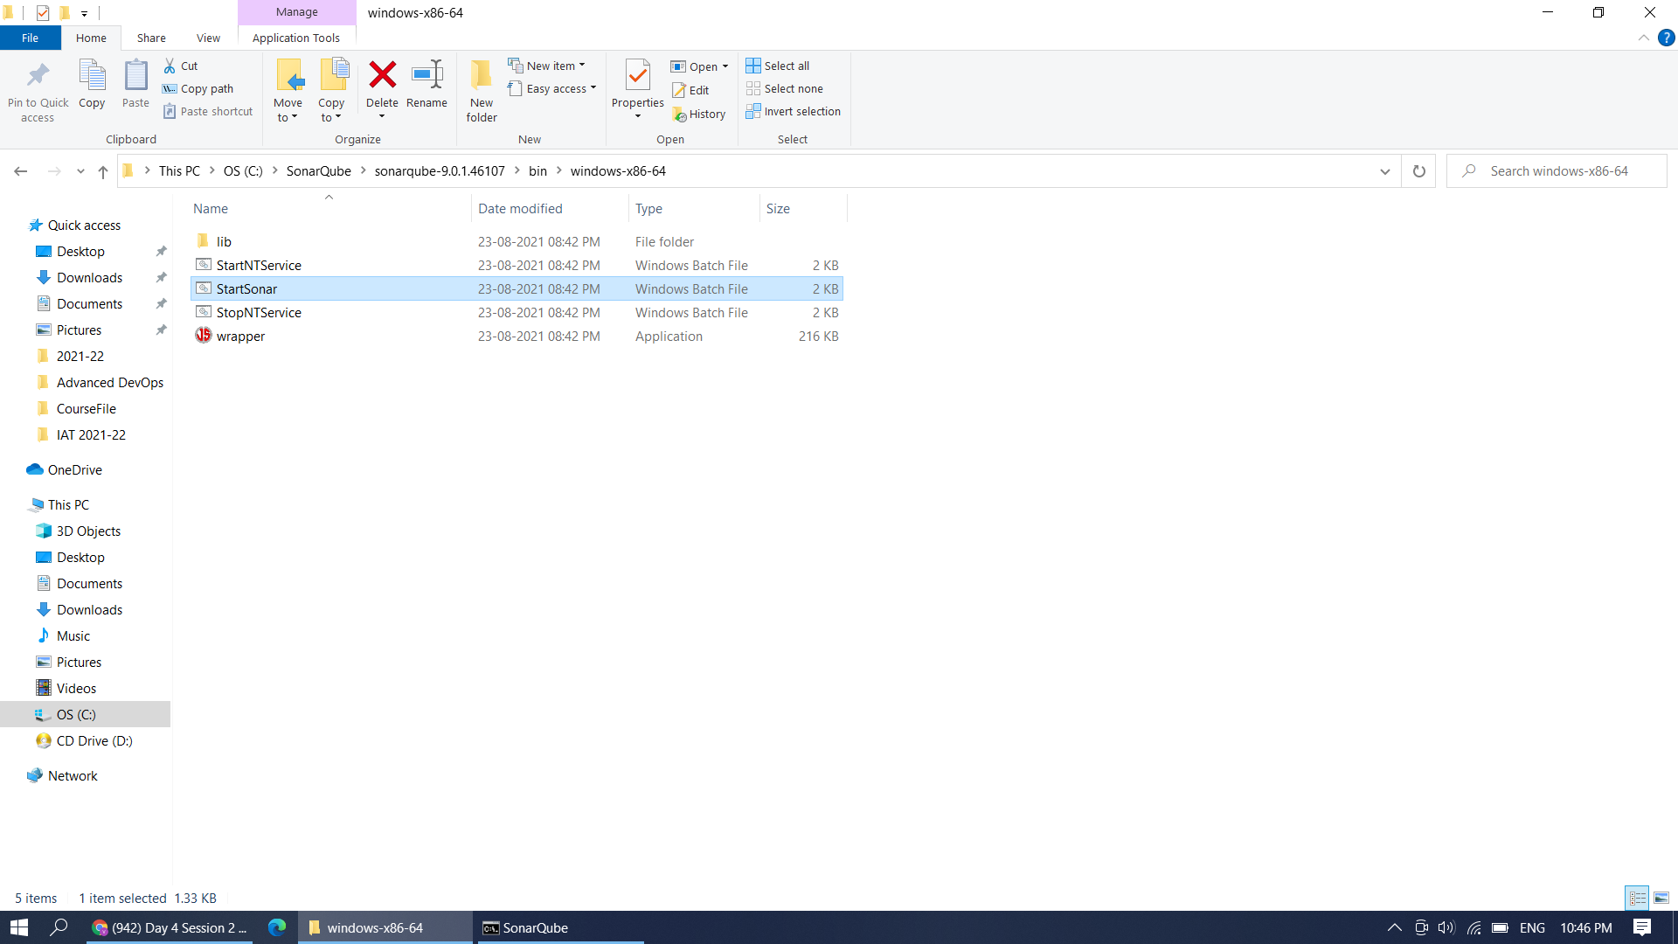

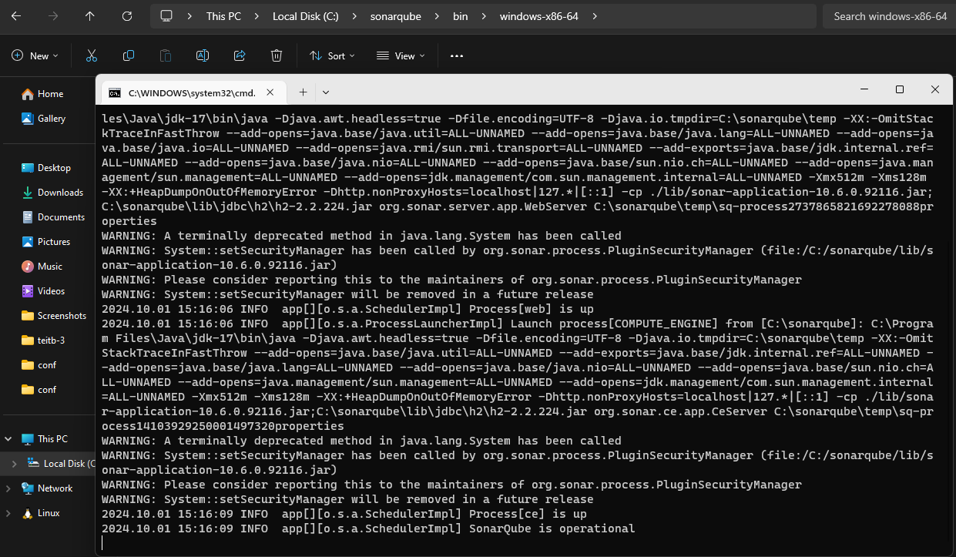

**Step 2: : on browser chk** [**https://localhost:9000**](https://localhost:9000)

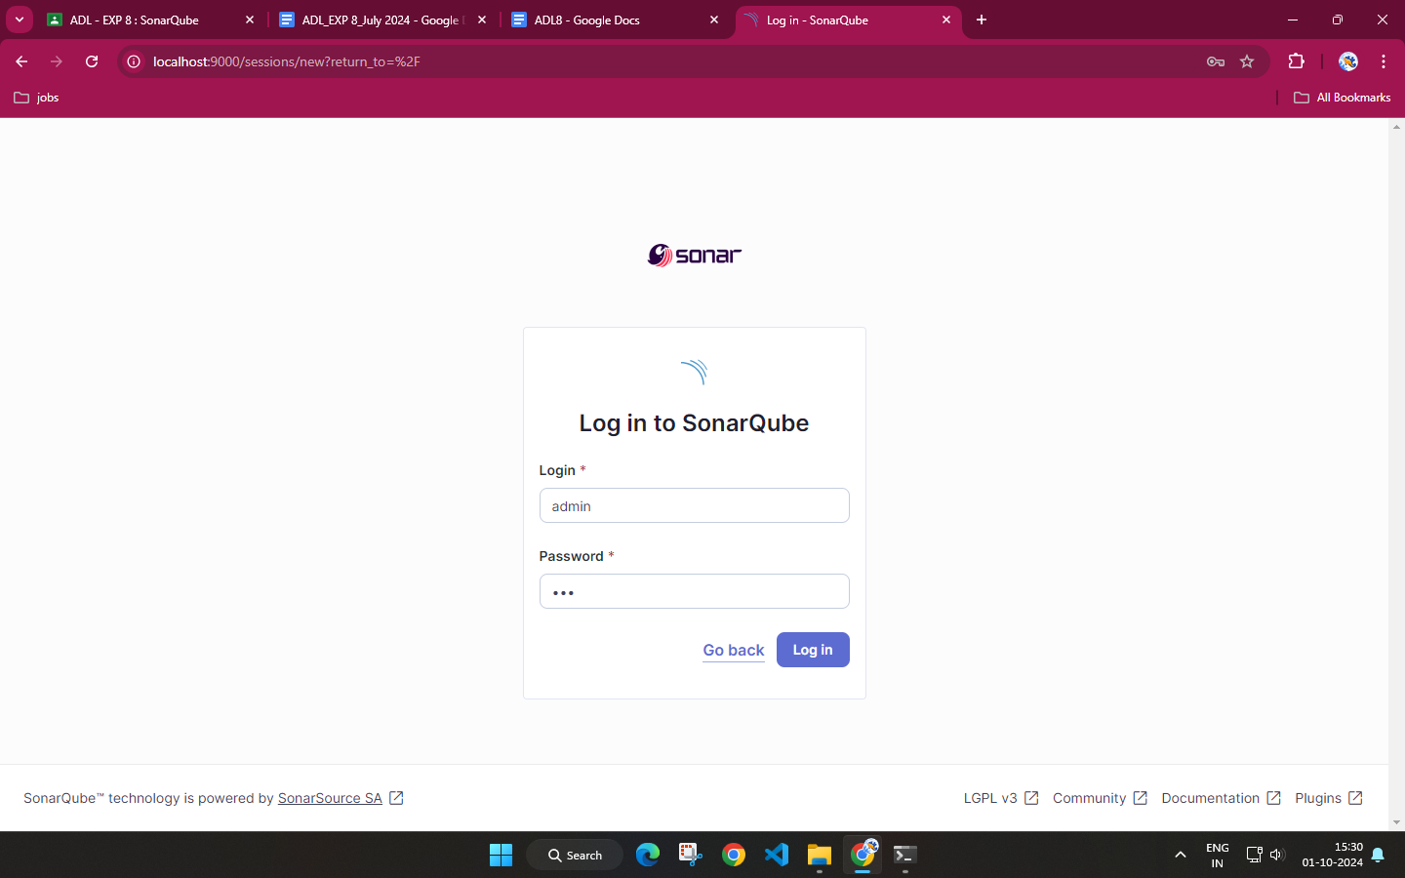

**Step 3: By default Username and Password is admin. You can change the password here.**

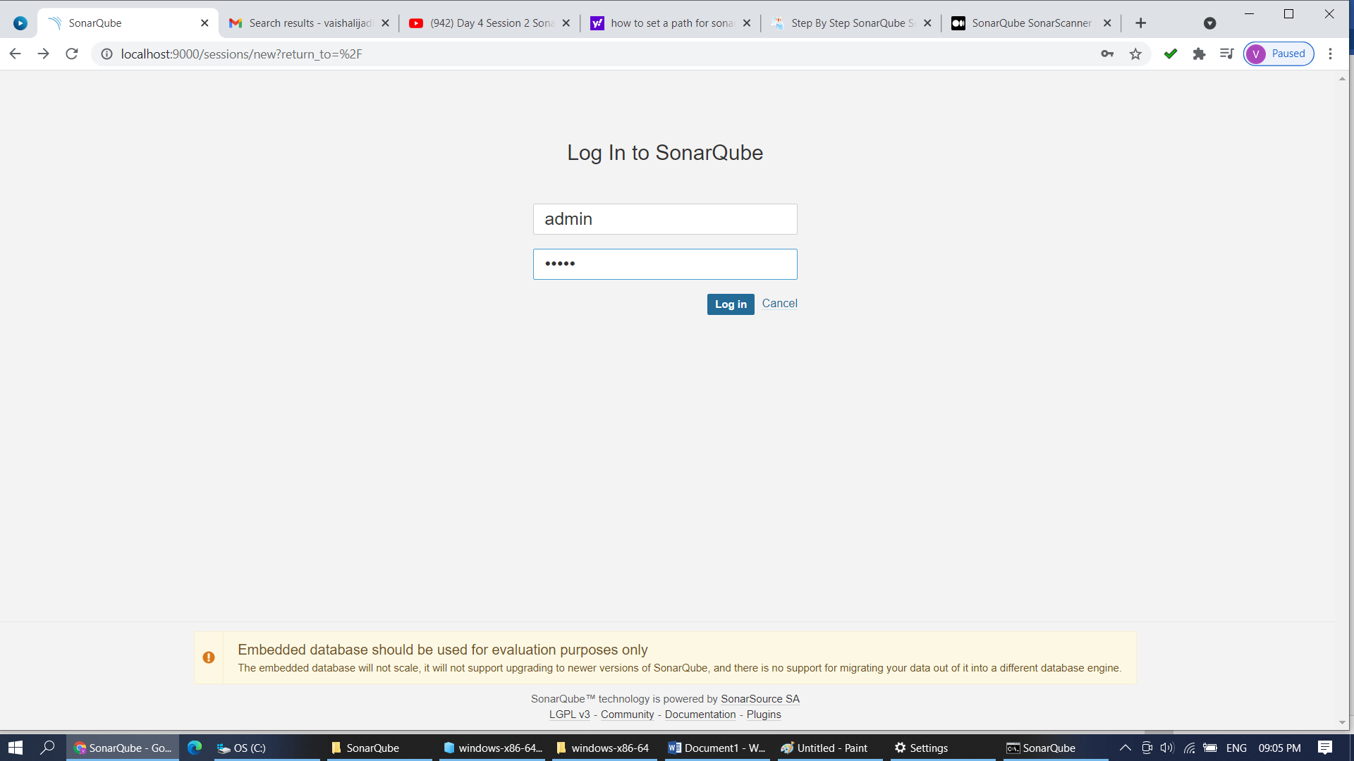

**Step 4: Login with new password.** 

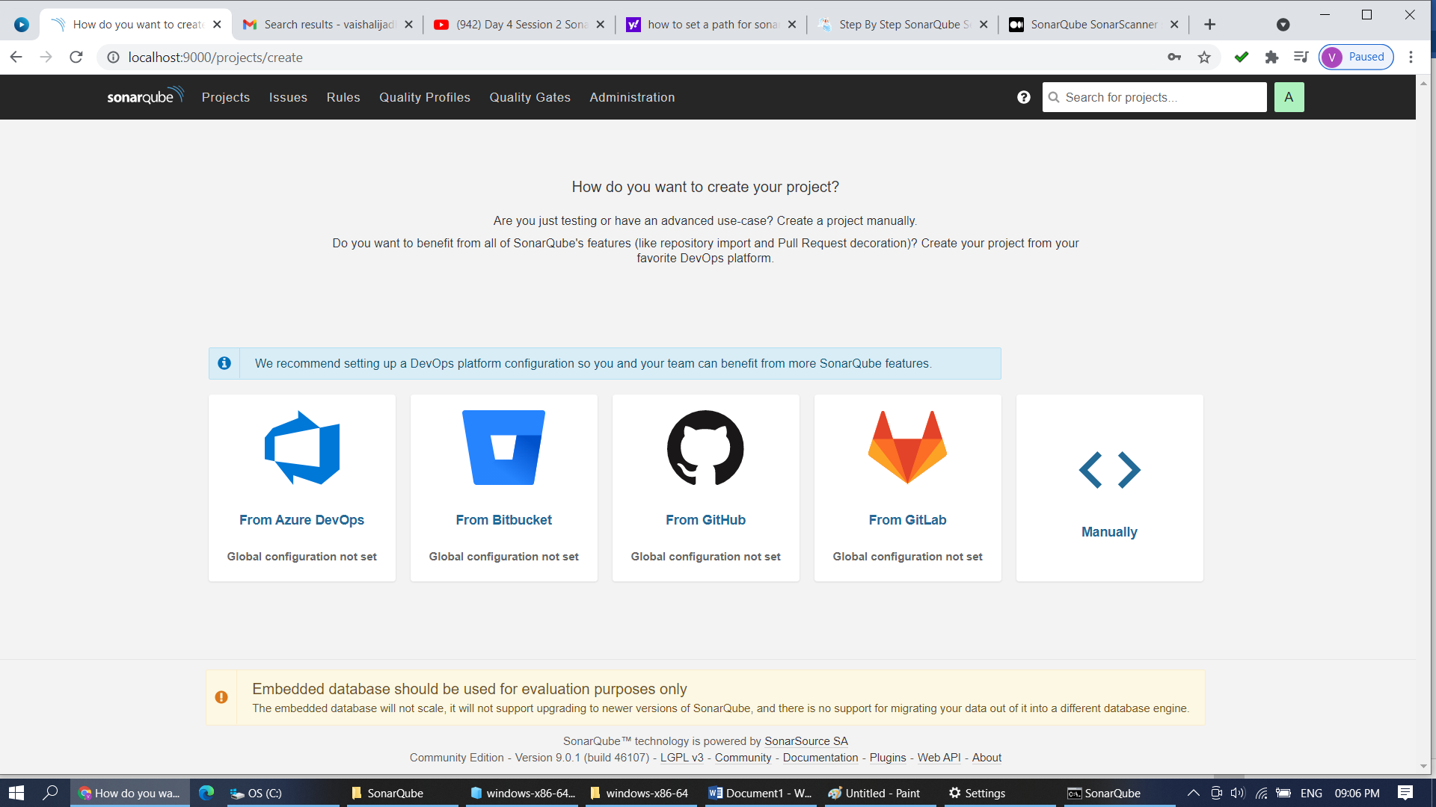

**Step 5: Click on Manually. Create a Project named SFIT_SAST**

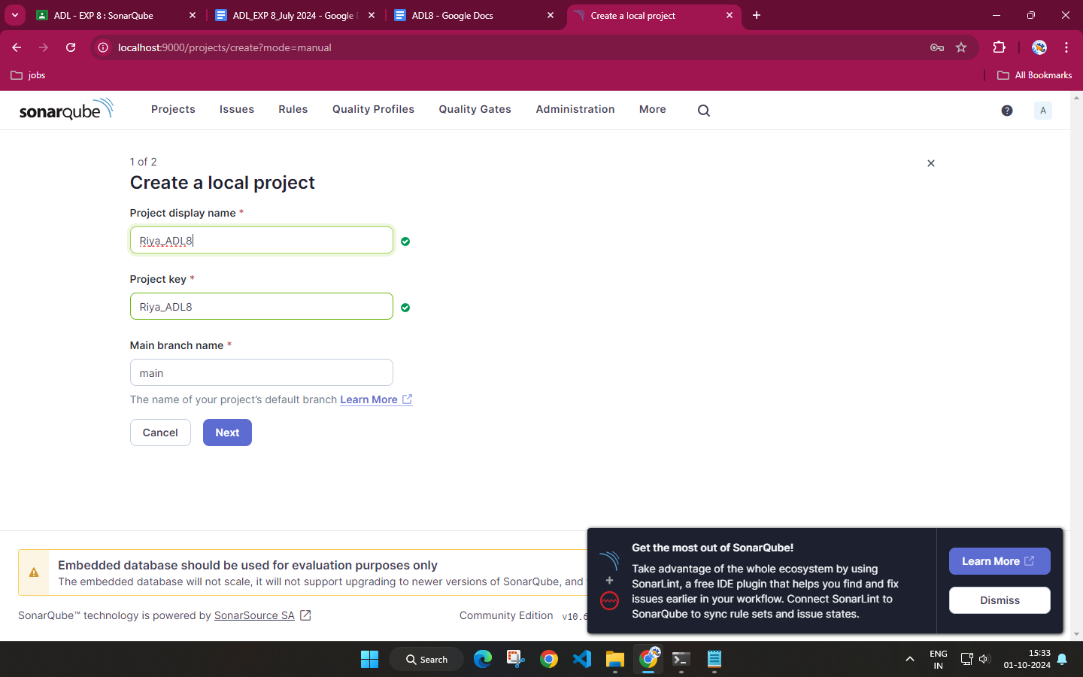

**Step 6: Click on Locally and given token name**

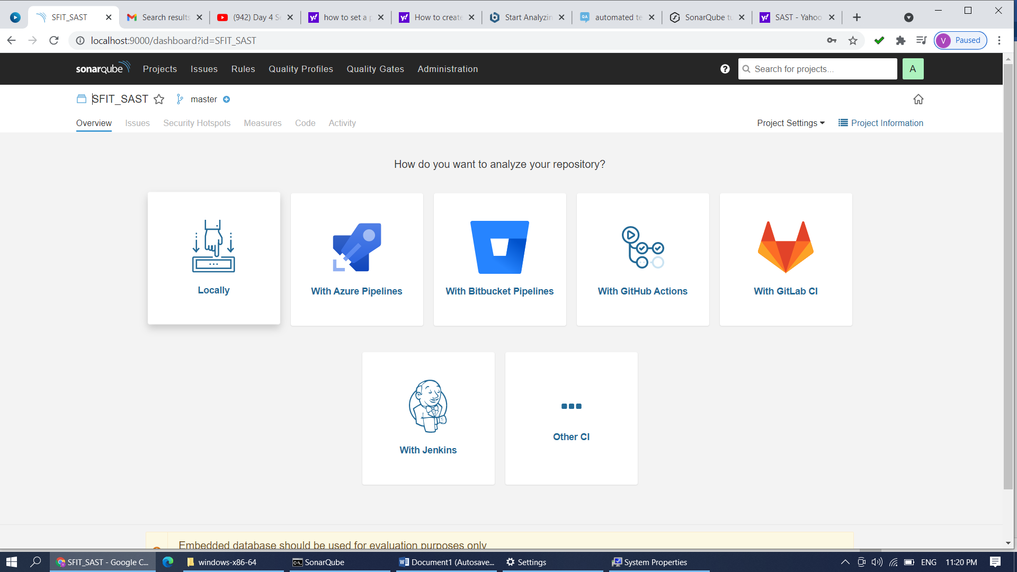

**Step 7: Give token name SFIT_SAST and continue**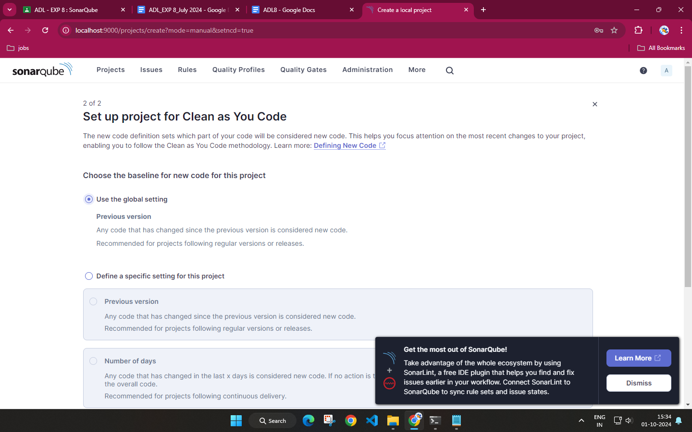

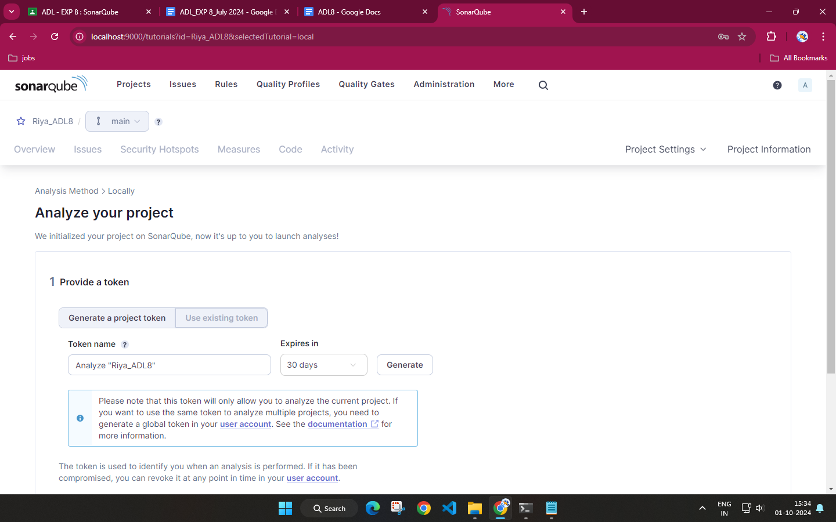

**Step 8: Select what type of project you want to test**

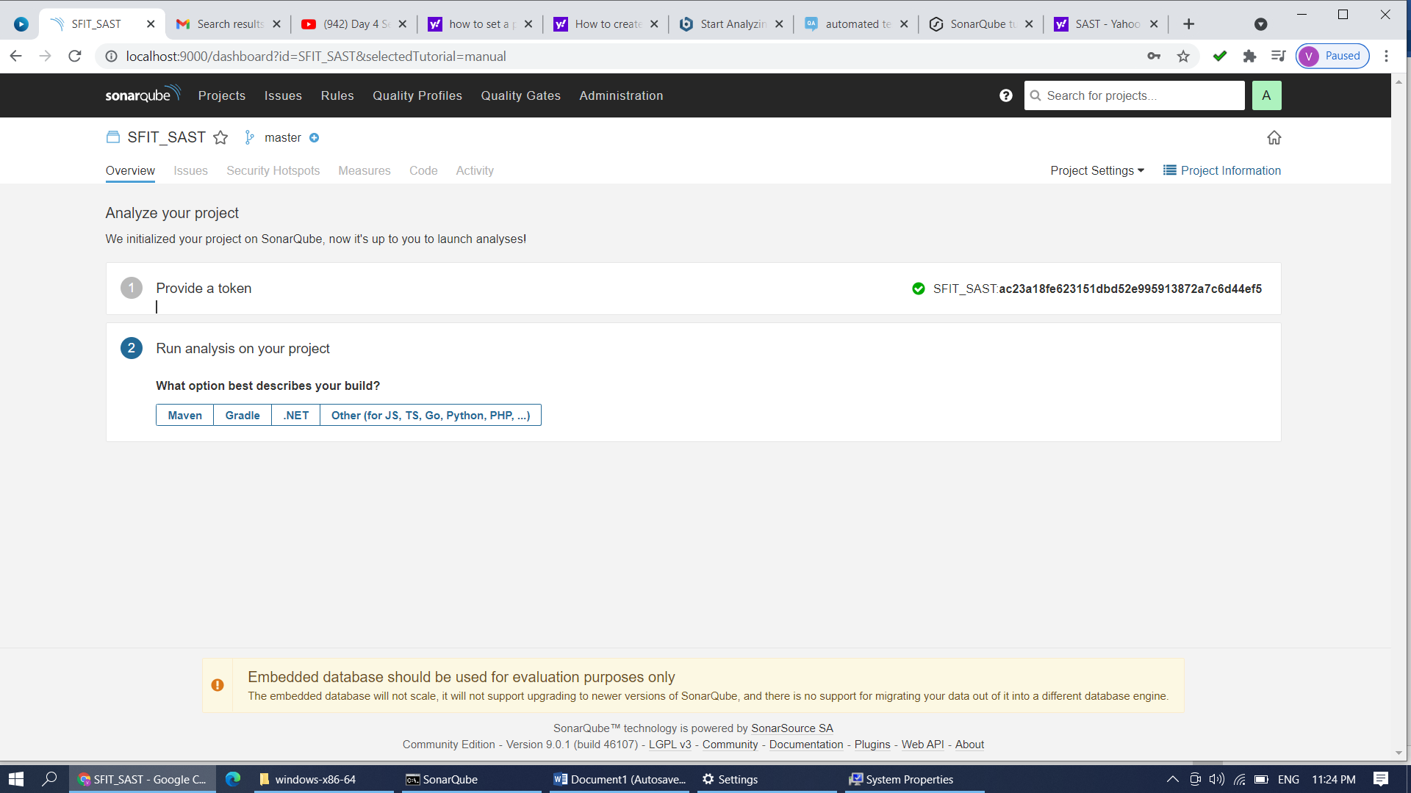

**Step 9: Click on Other and select OS as Windows**

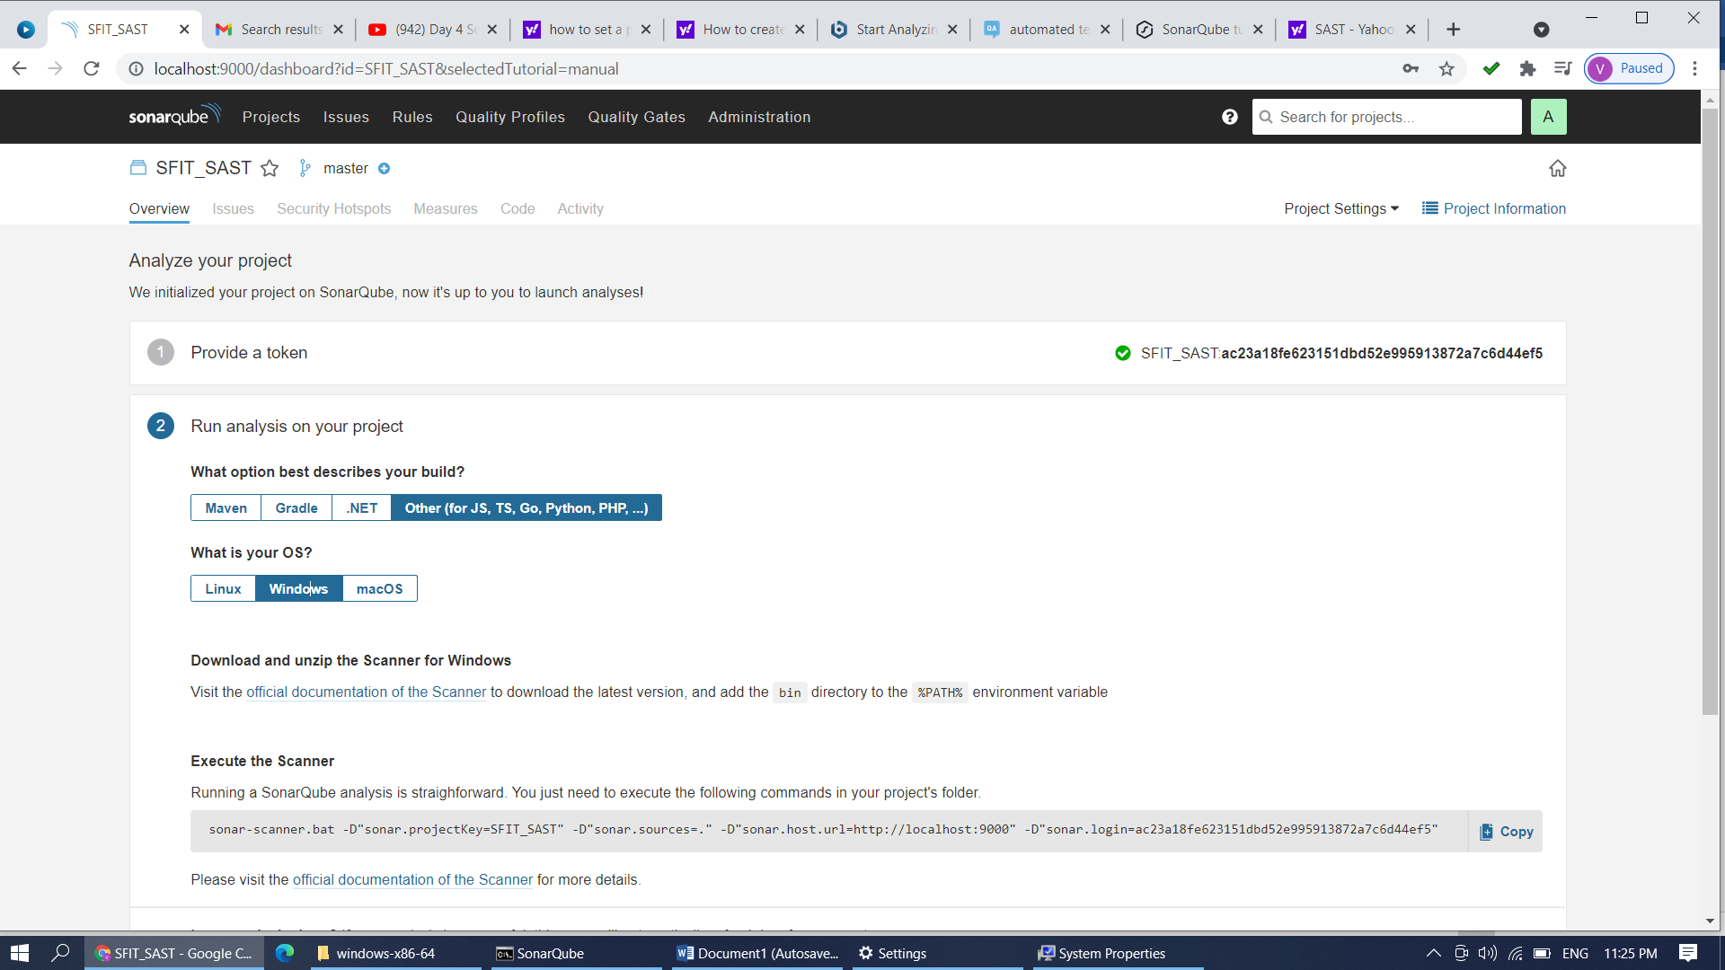

**Step 10: Copy that command …Open new command prompt and paste that command after configuration of scanner.**

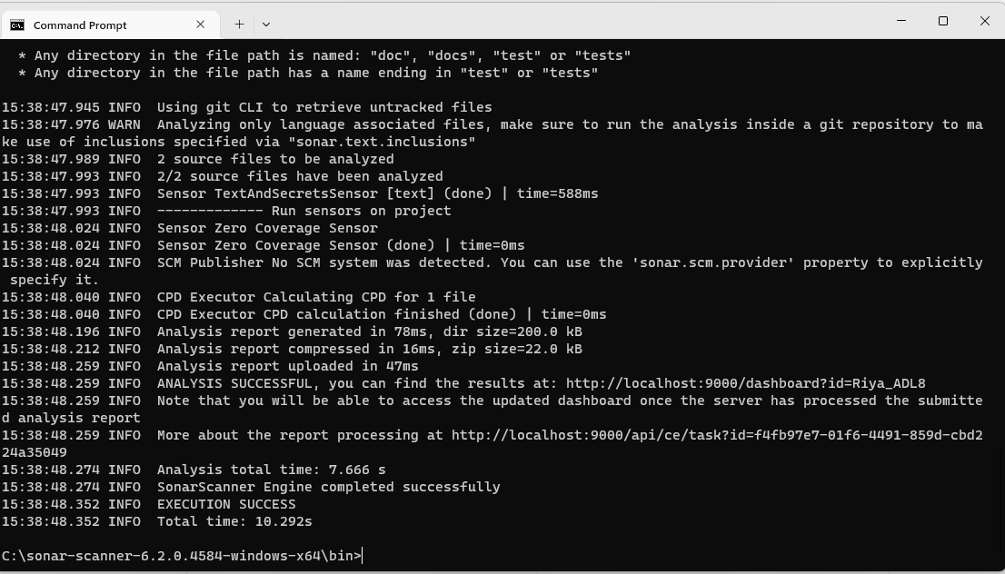

**Step 11: Create a folder in C:/SFITJobs/PY Scripts . Add python programs in to it (you can create Java Scripts folder and can add js files which are to be tested)**

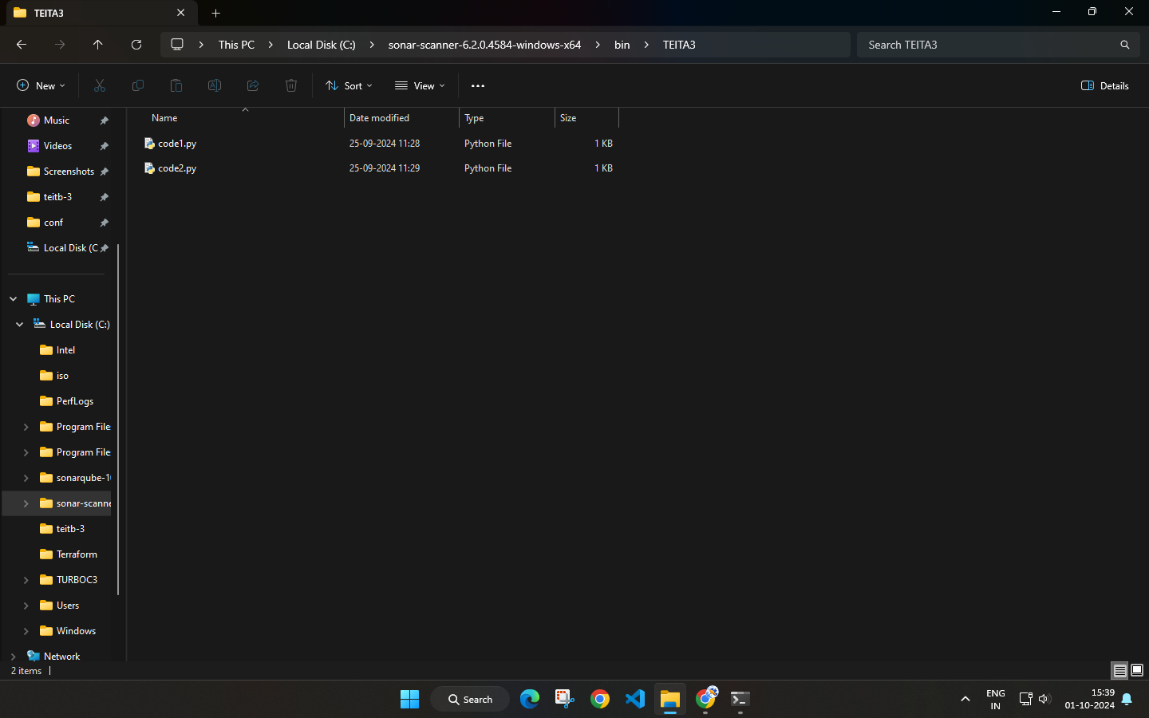

**Start configuration of the scanner. Add following lines to C:/SonarScanner/conf/Sonar-Scanner.properties**…Open that properties file **with Notepad** and do the following changes.

#Configure here general information about the environment, such as SonarQube server connection details for example

#No information about specific project should appear here

#----- Default SonarQube server

#sonar.host.url=http://localhost:9000

#----- Default source code encoding

#sonar.sourceEncoding=UTF-8

**sonar.projectKey=SFIT_SAST3**

**sonar.projectName=SFIT_SAST3**

**sonar.projectVersion=1.0**

**#sonar.projectBaseDir=C:\SFITJobs**

**sonar.sources=C:\SFITJobs\PY Scripts**

Step 12: Save the above file. Open new command prompt. Go to C:/SFITJobs/Py Scripts and Run the copied command (from step 10) from dashboard on it. It will generate the report.

C:/SFITJobs/PY Scripts >sonar-scanner.bat -D"sonar.projectKey=SFIT_SAST" -D"sonar.sources=." -D"sonar.host.url=http://localhost:9000" -D"sonar.login=edabde9219cd89080688d93f3ff57ee8ba4caaf4"

If Scanner is not get configured properly you may get an error.

Error File Screenshot: (Execution Failure)

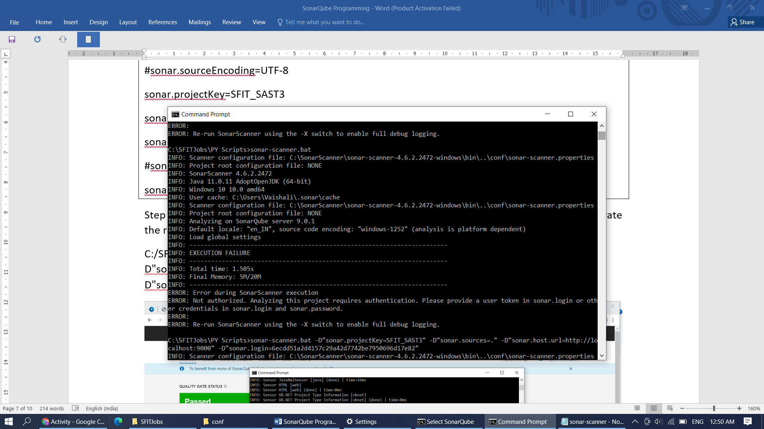

If no error in Sonar Scanner and SonarQube configuration then copied command will give output on dashboard. Command Prompt is showing Execution Success and dashboard will give Quality Gate Status : Passed

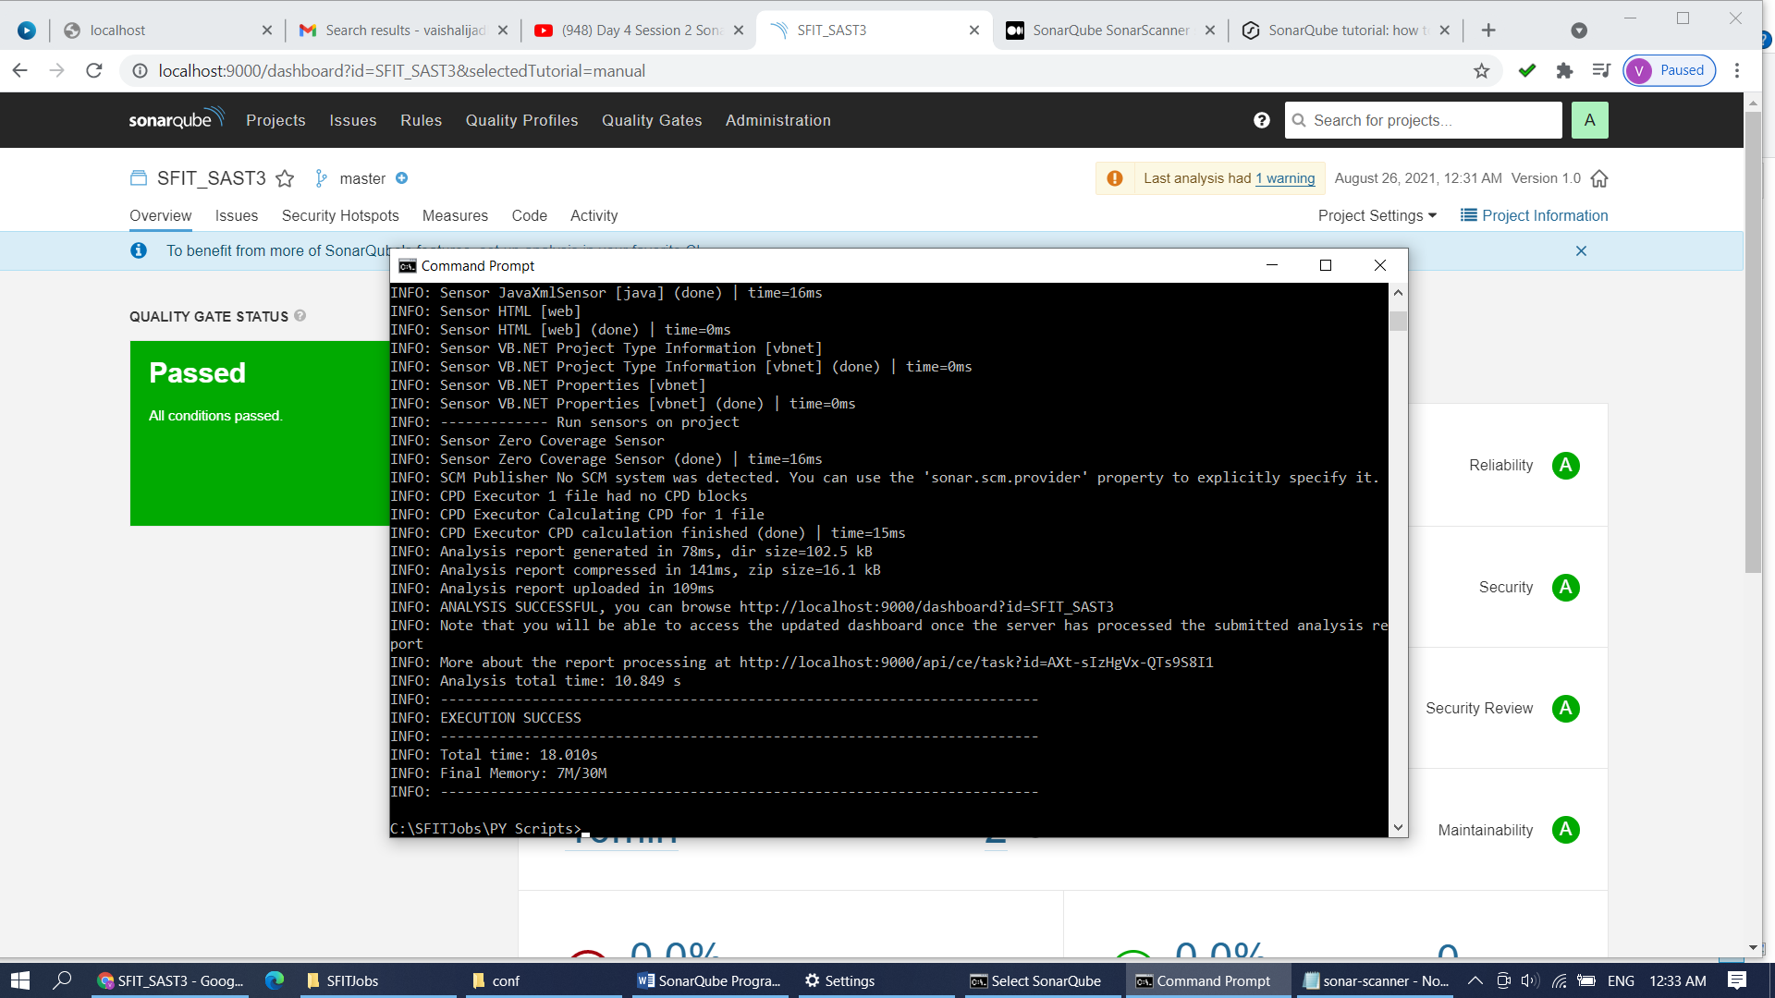

Check each tab i.e. Overview,issues, security hot spots, measures, code and activity.

Issues tab give 2 code smells in IRIs.py file. Click on it and check the unnecessary code in the file. Iris.py Sonar Scanner is recommending to remove these unnecessary import lines from the code file iris.py.

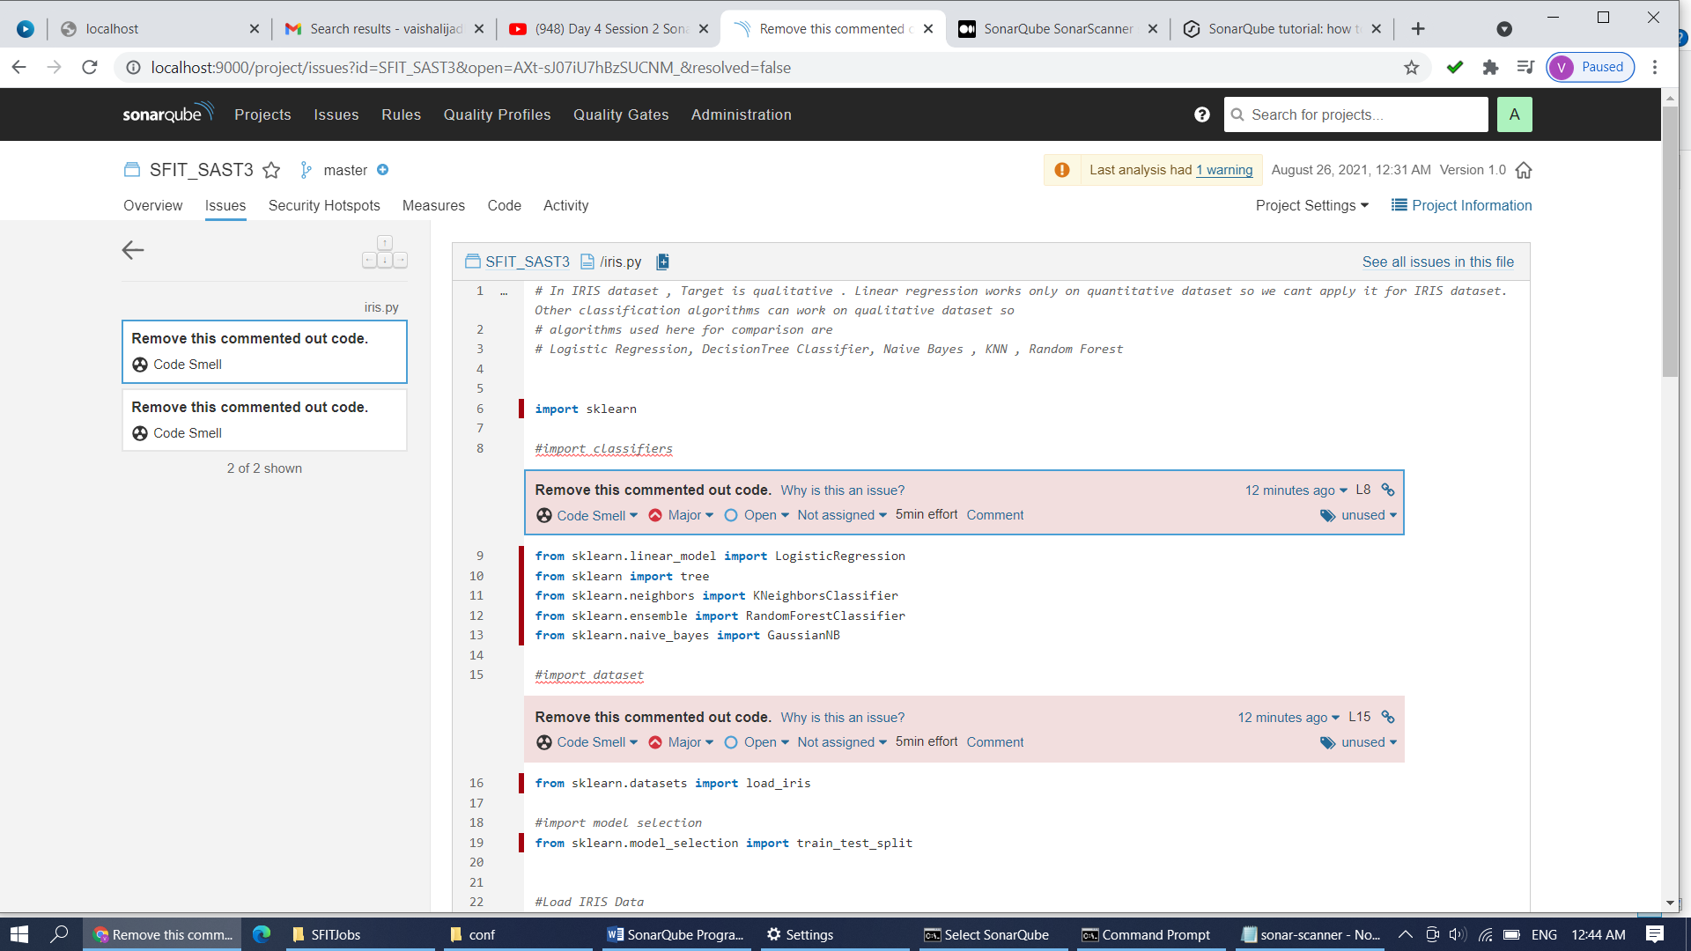

No security hotspots are seen in PY Scripts folder.

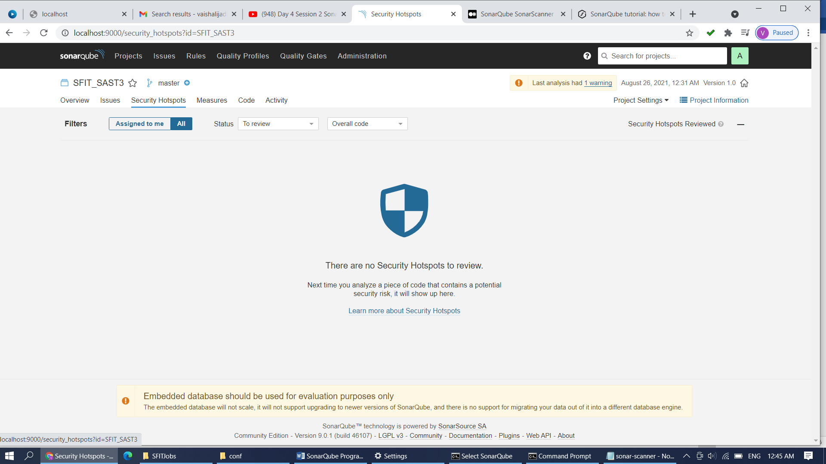

Risk is 0% while deploying PY Scripts folder.

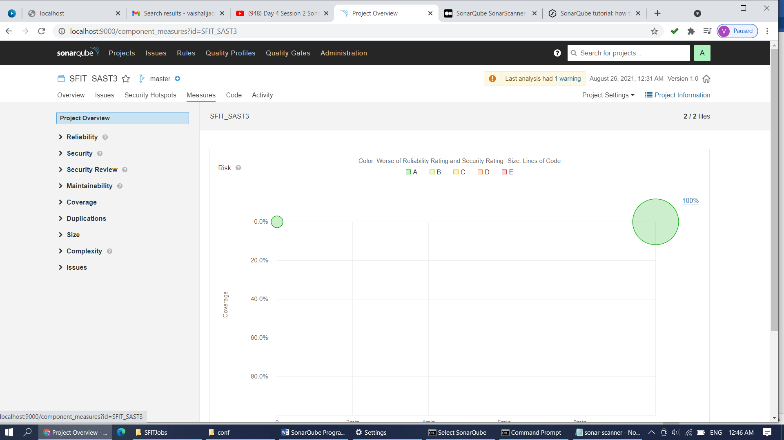

Py Scripts Folder contains two files iris.py and sum.py …iris.py contains 2 code smells.

Activity tab will give scan and test activity details. i.e date, time ,version of scanned file .

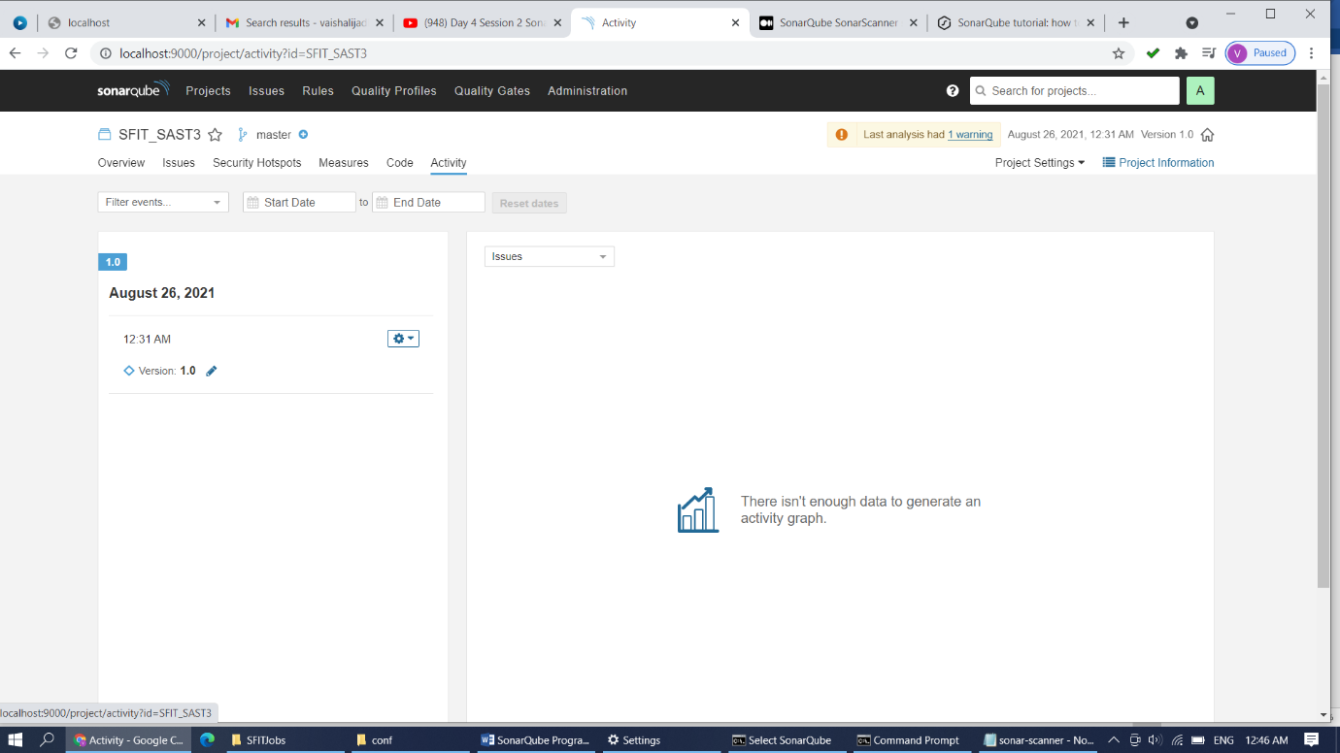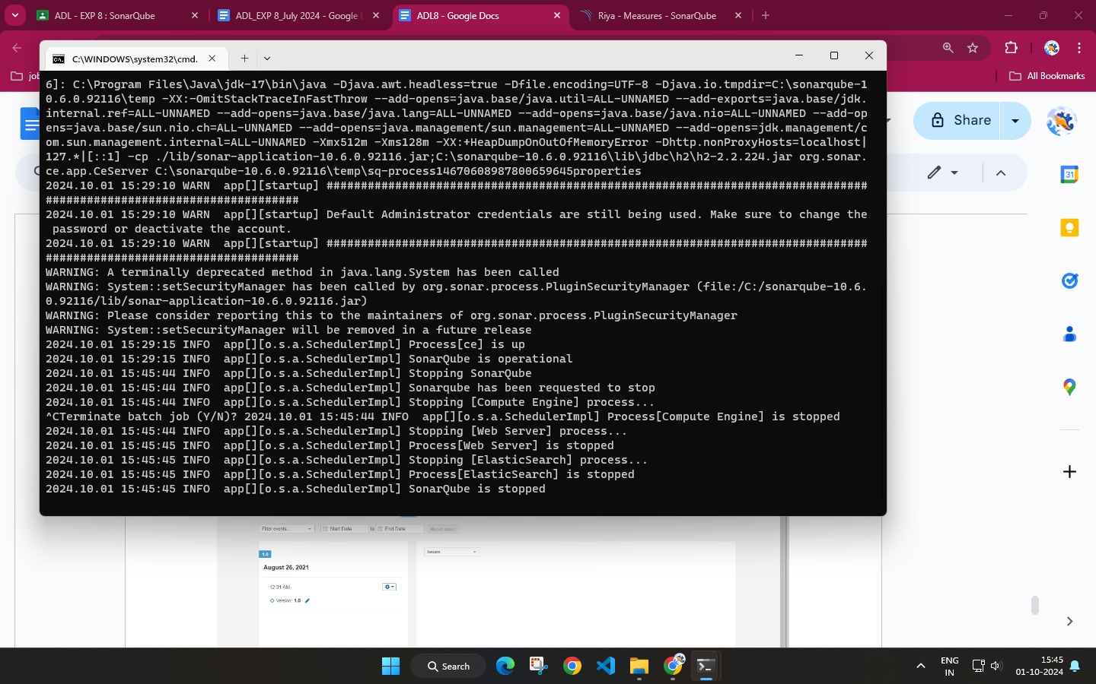

1. **Post-Experiments Exercise**
2. **Extended Theory:**

* what is Code smell? (To be written in hand)

1. **Questions:**(soft copy)

Q.1 List characteristics of good quality code.

Good quality code is essential for maintainability, scalability, and reliability. Some key characteristics include:

* **Readability**: Code should be easy to understand for other developers. Well-named variables, methods, and classes, as well as proper indentation and comments, help improve readability.
* **Maintainability**: The code should be easy to modify and extend without introducing bugs. This includes keeping functions small, adhering to design principles, and writing modular code.
* **Efficiency**: Good code should be optimized for performance, using resources like memory and processing power efficiently.
* **Simplicity**: Code should avoid unnecessary complexity. Simple, straightforward solutions are easier to maintain and debug.
* **Consistency**: Following a consistent coding style across the codebase makes it easier to read and reduces confusion when multiple developers work on the same project.
* **Testability**: Code should be written in a way that makes it easy to test. Functions and modules should be independent and have well-defined inputs and outputs.
* **Reusability**: Good code should promote reuse, avoiding duplication. Reusable components save time and reduce errors in future development.
* **Scalability**: Code should be designed in a way that it can handle increasing loads or be extended without major changes.
* **Adherence to Standards**: Following industry standards or project-specific guidelines ensures consistency and reliability across the code.

Q.2 Explain in short key traits to measure for higher quality

* **Modularity**: The code is broken into small, independent modules or components, each with a specific responsibility. This promotes reusability and easier debugging.
* **Low Coupling and High Cohesion**:

~**Low Coupling**: Dependencies between modules should be minimal, so changes in one module do not affect others.

~**High Cohesion**: Each module should focus on a single task, making it more understandable and manageable.

* **Code Coverage**: The extent to which the code has been tested. High code coverage means a greater portion of the codebase has been executed during testing, reducing the chances of bugs.
* **Complexity**: Lower complexity in code means it's easier to understand, test, and maintain. Metrics like cyclomatic complexity help measure how many paths exist in a program, with fewer paths being easier to manage.
* **Performance**: The responsiveness and efficiency of the code when executing tasks. This can be measured using performance profiling tools to ensure that the code handles resources optimally.
* **Security**: Code should be free of vulnerabilities, such as those leading to SQL injection or cross-site scripting (XSS). Secure coding practices should be followed to ensure resilience against attacks.
* **Documentation**: High-quality code is usually accompanied by well-written documentation, both inline (comments) and externally (API documentation, README files), which helps others understand and use the code.
* **Scalability and Flexibility**: Code should be easily extendable without requiring significant changes, especially as the system grows or requirements change.
* **Maintainability**: This includes the ease with which the code can be updated, enhanced, or fixed. Maintainable code often follows clean coding practices and design principles like SOLID.

**C. Conclusion:**(To be written in hand)

Write the significance of the topic studied in the experiment.

1. **References:**

<https://medium.com/swlh/sonarqube-part-2-features-of-sonarqube-installation-and-some-practice-on-sonarqube-d523ae9a998a>

<https://docs.sonarqube.org/latest/>

<https://www.codeusingjava.com/interview/sonar>

---------------------------------